Project Description

Bob---The feast of bee

PROJECT DESCRIPTION

The growth of Bee

2023.10.22

ELEVATOR PITCH:

The project will lead you to a fantastic natural world of the bee,where you can explore the upbringing of the small bees with immense freedom.What’s more,their humanized reward would definitely surprise you.In this work,you can fully experience the pain and gain,felling the animal’s humanized emotions and behavior.

Abstract:

The project beginning with small bees looking for the food,and you acts an feeder to help them grow up.When they have reached the “food”you provided, they will grow up and dance in a particular movement,which calls the” wagging dancing”,which is a special dancing in the nature for the bees to spread the information of the food.It is absolutely simulated as the nature.You can even see the smiling when they have the food and grow up.The last but not the least,the next time you approach to them,they will be grateful and in turn to help you to grow up,which also simulate the pollination.And finally the fantastic flower will undoubtedly surprise you a lot.

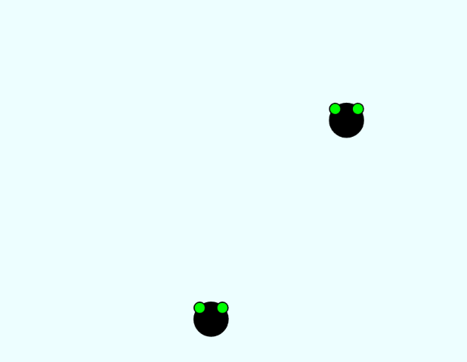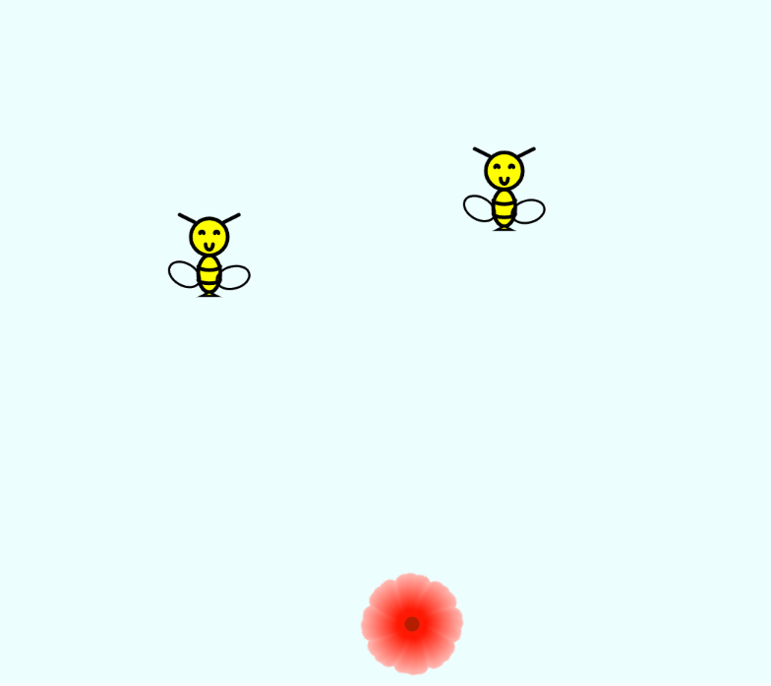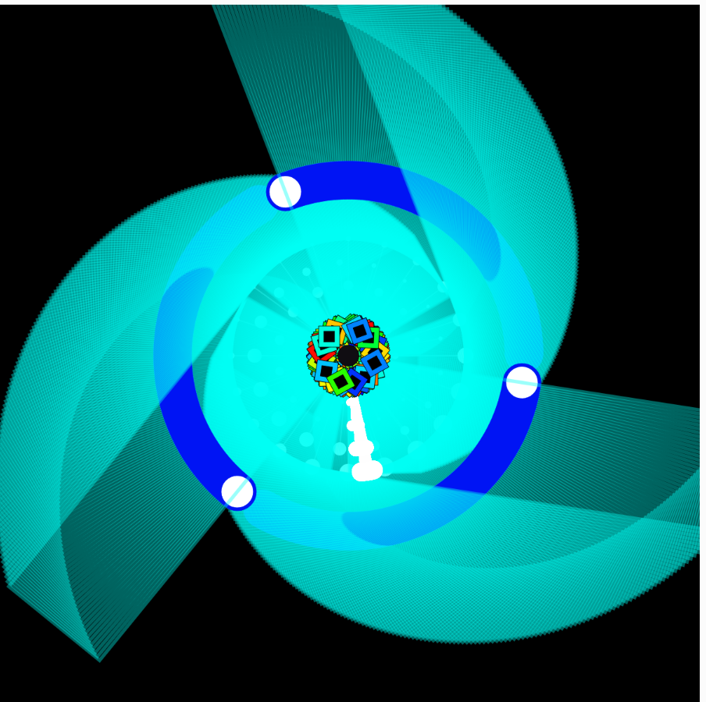

1) Process: Design and Composition

For the inspiration,I initially want to create a interesting story in the nature.And I recall the bees which are very popular in my hometown.They are very cute and hard-working.I also have learned that they will using a special dancing to spread the information.Combing all this, it occurred to me that I can create a process of the growth of the bee.As for the interaction.It is good for the audience to act as the food that the bees need.And control the food to upbringing the bees and experience the fun in it.And that is the first thought.Afterwards,I thought that it will be a good idea to give some rewards for the feeder,which is more reasonable.So I add more elements to change the flowers shapes as a reward from the bees.To be honest , I want to show the entire process of the growth of the bees,including the transformation of their wings,their body,etc.But if I want to realize it,it will cost a lot of time to draw frame by frame,because it doesn’t work with the for loop,rotate,etc.It need to draw frame by frame so I failed it.I reckon it the very special element I add to my works is the humanized emotions and behavior,which can be proven by the reward of the bees just like they are grateful.It is a little special.

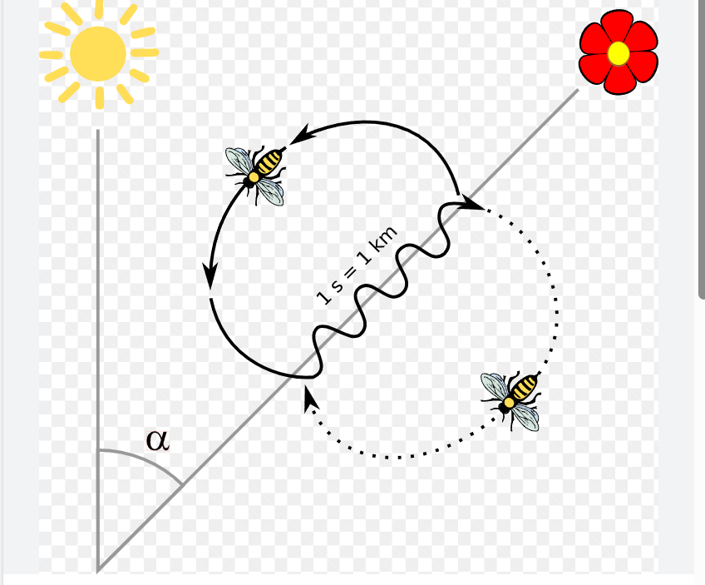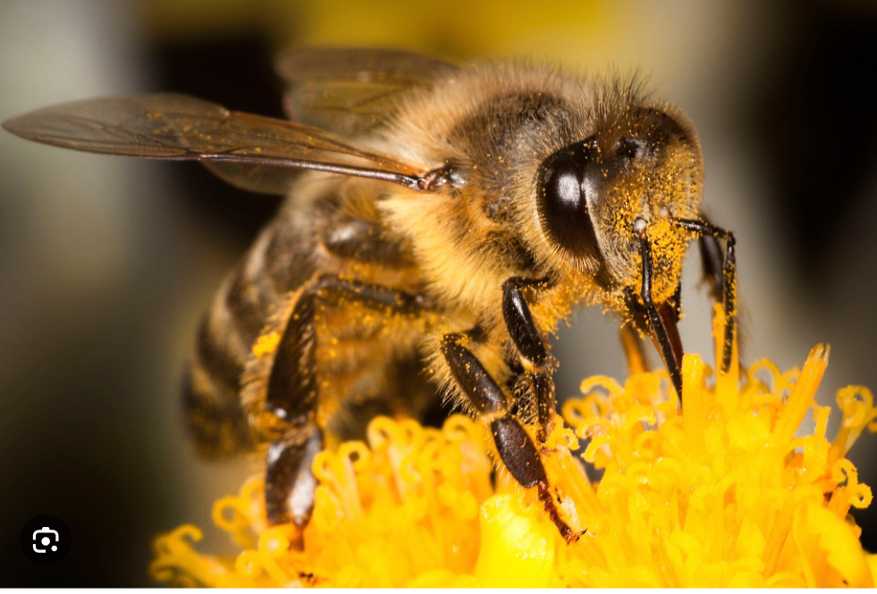

2) Process: Technical

As for the challenges,there are a lot of challenge I have met.And I cost a lot of time to debug.And among which the most impressive one is to combine two canvas into one.The first one needs to refresh the background while the other doesn’t need to do.So if I just duplicate and paste it,it will has some bugs.And after long time communication and trying ,I finally uses a new methods which can create a new graphics just like overlap two canvas and it works well! And there are also some pity just like I learned that the function dist can calculate the distance of the two dots.while when I use the ellipse to draw the bees and other shapes to draw the body,I can’t calculate it for that I can confirm the right rots.And I finally compromise the rough calculation.I reckon it better if I can use more new codes which can smoothly show the transformation of the bee’s growth and if it doesn’t need to draw frame by frame will be better. Along the way ,I discover that in the p5.js,we still have a lot of new coding with many fantastic utilize we have never learned.And maybe I need to learn more by myself in the future.It is hard but very interesting and I look forward to it very much!

3) Reflection and Future Development

All in all,although this process is full of difficulties,but thanks to my professor moon and assistant peer carrot,I come across all of them one by one.And I constantly add more elements that burst out from my brain along the way.Also it is very [grueling](javascript:;) and [tormenting](javascript:;) when founding some bugs or doesn’t fulfill what I thought in my mind,but it really brings more inspirations and create a new world for me when I learn some new codes or learn some [mathematical thought](javascript:;) to create some patterns.For the project ,I think the basic story I want to create is already fulfilled,and the basic emotion in the story I want to show also works.However,there are many discontent,especially the too simple outline of the bee and not have a smooth growth of the bee.

As for the suggestions from my peers and instructors.First of all,it is a little [monotonous](javascript:;) to just control the flower by the key,it would be better to add some elements like the the wind blew the flowers up.What’s more,the wagging dancing is too light to distinguish,maybe I need to draw the trail of the bees.Finally,more interactions between the flower and the bees would be more better rather than just collision.I think they are all good suggestions.And maybe I would add more elements like the eating process of the bees,the pollination process,the more fantastic movement and changes included.